AWS Cloud

AWS Free Tier Account
Create Root User Account
Connect to https://aws.amazon.com/console/ from your browser
Click on “Sign in to the Console” link on the right top of corner.
Click on Create a new AWS Account
Enter your email address, password and AWS account name.
Choose Account Type as “Personal” and enter required details. Click on ‘Create Account and Continue’.

Enter Debit OR Credit card number along with the CVV shown in your debit/credit card.
Click on ‘Verify and Add’ button. Wait for OTP and enter the OTP details to proceed further. You might be charged Rs 2/- from your account, but they will revert it back.

Enter your phone number and select SMS option (verification code to send) in Confirm your identity screen. Wait for the verification code to receive through SMS to your registered phone number. Enter the 4-digit verification code and proceed.

Choose the Basic plan once the verification is over. Enter the Role and Interests of your choice and Submit.
Sign in (Sign in to the Console button on the top right corner) with your Root User and Password. Select the option as ‘Root User’, enter your email and password.

Create Admin user for Terraform
Click on Services and enter ‘IAM’ in the Find Services search option.
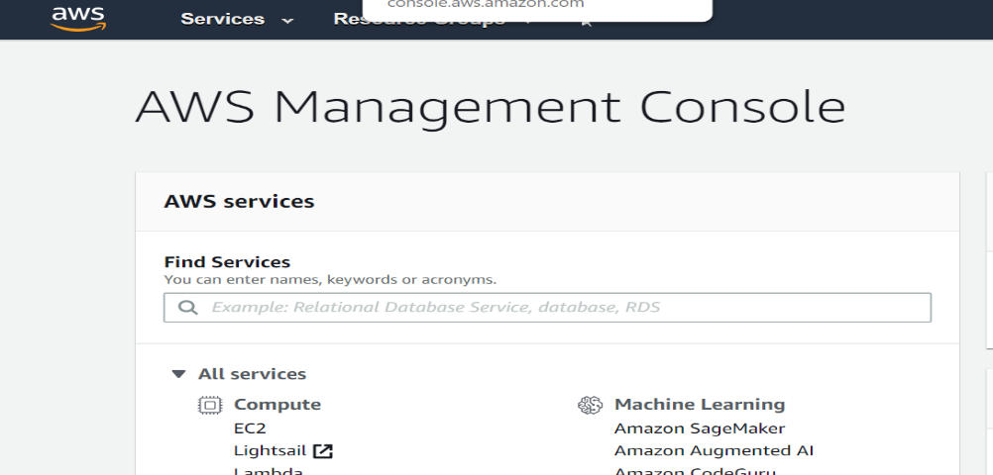
Click on Users -> Add User
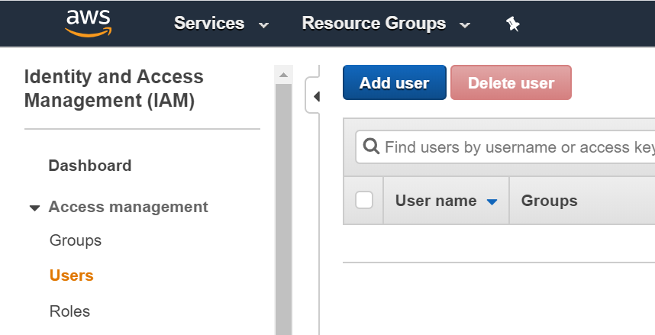

Enter the username as ‘terraform’ and select ‘Programmatic Access’ and ‘AWS Management Access’. Provide a password by selecting ‘Custom Password’. Deselect the ‘Require Password Reset’ option.
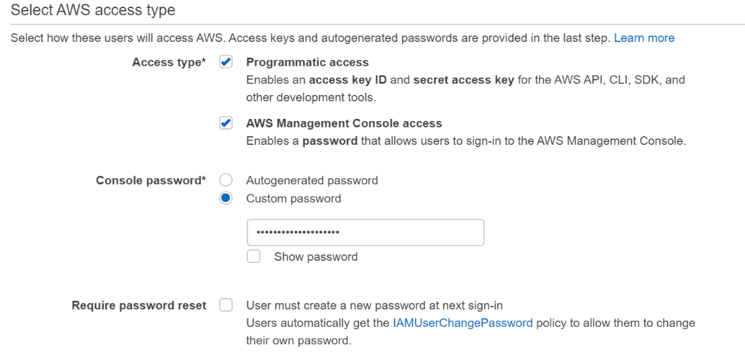
Click on ‘Next Permissions’ button
Click on ‘Attach Existing Policies Directly’ tab and select below 4 policies by typing and selecting the permissions.
Enter S3full and it will show ‘AmazonS3FullAccess’ permission. Choose the permission by clicking the selection option. Repeat the same procedure to add the below permissions.
(Note: - Make sure you select the permission before entering the Next permissions on the filter option)
AmazonEC2FullAccess, IAMFullAccess, AmazonRoute53FullAccess, AmazonRDSFullAccess, AmazonDynamoDBFullAccess

Proceed to ‘Next Tags’ button and tag the user with a key as Name as value as terraformadmin
Click on ‘Next Review’ and make sure the we have the required permissions added. If you see something missed, go to previous screen and add them.
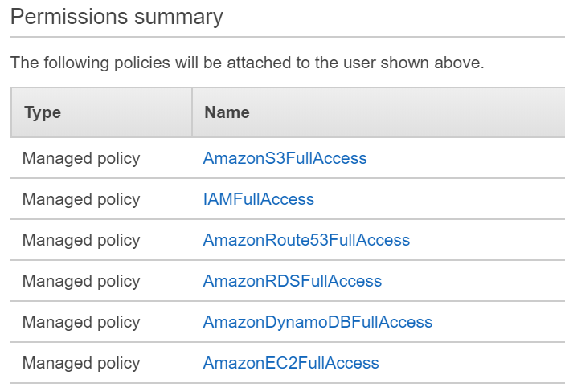
Click on ‘Create User’ to complete the Terraform Admin user creation.
Verify Important: - Download the csv file shown in the success screen. Make a note of the Access Key Id, Secret Access Key and the Console URL safely. Use this Console URL to access the AWS console next time.
SignOut from the root user and login with the Console URL copied.
Enter the IAM user and password and login to verify.

